CO1 Assessment Tool 2

Agile Sprint Planning & User Story Workshop

SMART VERTICAL FARMING AUTOMATION PLATFORM
Name: G. Akshya Reg No: 192425132
Slot-D Course Code: CSA1007

1. Project Vision/Introduction
Vision: Build an IoT and AI based platform that automates vertical farming by monitoring environmental conditions, optimizing irrigation, predicting crop health, automating lighting, generating reports and notifying operators.
Objectives:
• Monitor environmental conditions
• Optimize irrigation
• Predict crop health
• Automate lighting control
• Generate production reports
• Notify farm operators

2. Stakeholder Identification
Farm Owner, Farm Operators, Agricultural Experts, IoT Engineers, System Administrator, Customers and Government. Their roles include monitoring, maintenance, decision-making, compliance and quality assurance.

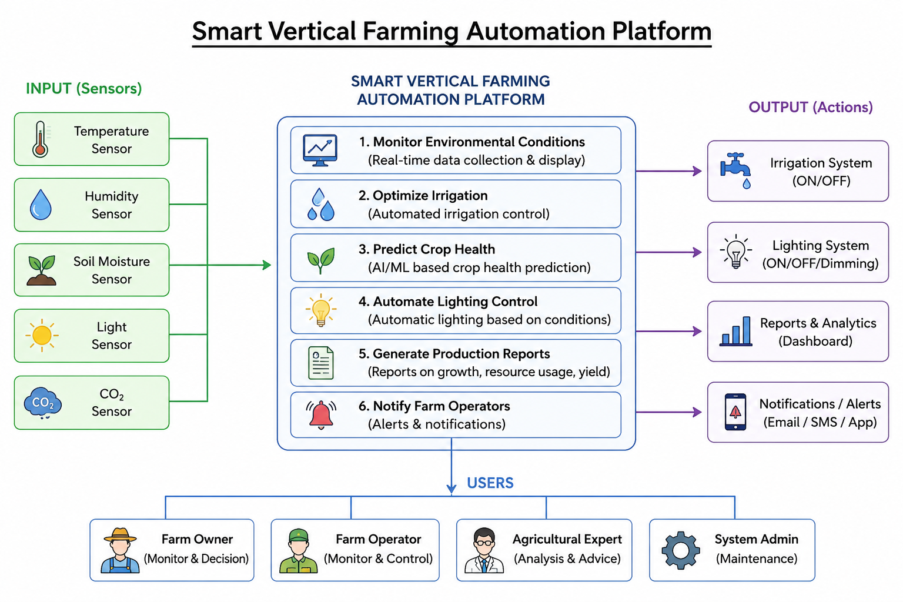

3. Epics and User Stories
Epic 1: Environmental Monitoring
- As a Farm Operator, I want to monitor temperature, humidity and soil moisture so that I can maintain ideal crop conditions.
Epic 2: Smart Irrigation
- As a Farm Operator, I want irrigation to start automatically so that water is not wasted.
Epic 3: Crop Health Prediction
- As an Agricultural Expert, I want AI to predict crop diseases so that preventive action can be taken.
Epic 4: Lighting Automation
- As a Farm Operator, I want lighting to switch automatically so that crops receive sufficient light.
Epic 5: Reporting & Notifications
- As a Farm Owner, I want production reports and instant alerts so that I can monitor farm performance.

4. Acceptance Criteria
- Given sensors are connected, when dashboard opens, then live values are displayed.
- Given moisture is below threshold, when detected, then irrigation starts.
- Given disease symptoms are detected, When AI completes analysis, then crop health status is displayed.
- Given light intensity is low, when threshold is crossed, then grow lights switch ON.
- Given abnormal conditions occur, when detected, then notification is sent.

5. Product Backlog
Must Have: Monitoring, Irrigation, Login, Notifications.
Should Have: Crop Health Prediction, Lighting Automation.
Could Have: Reports.
Won't Have: Drone Integration (Sprint 1).

6. Sprint Backlog
Tasks:
• Create Login Module
• Develop Sensor Dashboard
• Implement Irrigation Logic
• Integrate Sensor Database
• Test Modules
• Prepare Documentation

7. Story Point Estimation
- Monitoring-8
- Irrigation-5
- Crop Prediction-8
- Lighting-5
- Reports-3
- Notifications-3
- Fibonacci estimation based on complexity and effort

8. Sprint Goal & Deliverables
Goal: Deliver an MVP capable of environmental monitoring and automated irrigation.
Deliverables:
1. Login Module
Provides secure authentication for users before accessing the system. It ensures that only authorized users can use the platform.
2. Sensor Dashboard
Displays real-time sensor data such as temperature, humidity, soil moisture, and light intensity. It helps users monitor farm conditions efficiently.
3. Smart Irrigation
Automatically controls irrigation based on soil moisture levels. This reduces water wastage and ensures healthy crop growth.
4. Basic Notifications
Sends instant alerts when abnormal conditions are detected, such as low moisture or high temperature. This enables quick corrective action.
5. Testing Report
Documents the testing performed on all developed features. It records test results, identified issues, and confirms system functionality.
6. Sprint Review
Summarizes the work completed during the sprint and demonstrates the developed features. It also collects stakeholder feedback for future improvements.

Conclusion
The Smart Vertical Farming Automation Platform is a solution that improves farming through automation and real-time monitoring. By following Agile Sprint Planning, the project ensures efficient development, better collaboration, and continuous improvement.
I G. Akshya (192425132) certify that this submission is my
original work and that I have adhered to the guidelines specified for this assessment.
I understand that any violation of academic integrity rules will result in disciplinary
action.
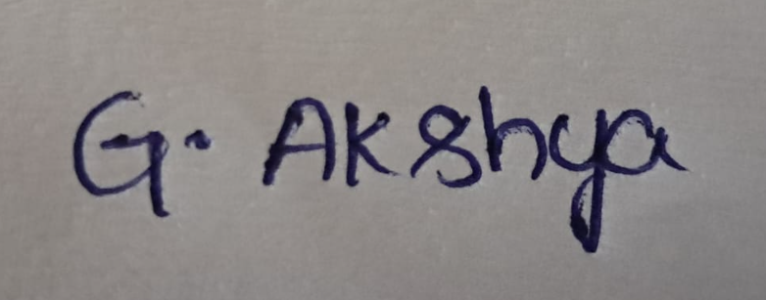
Signature of the student: G. Akshya

